Entry Planning Sheet

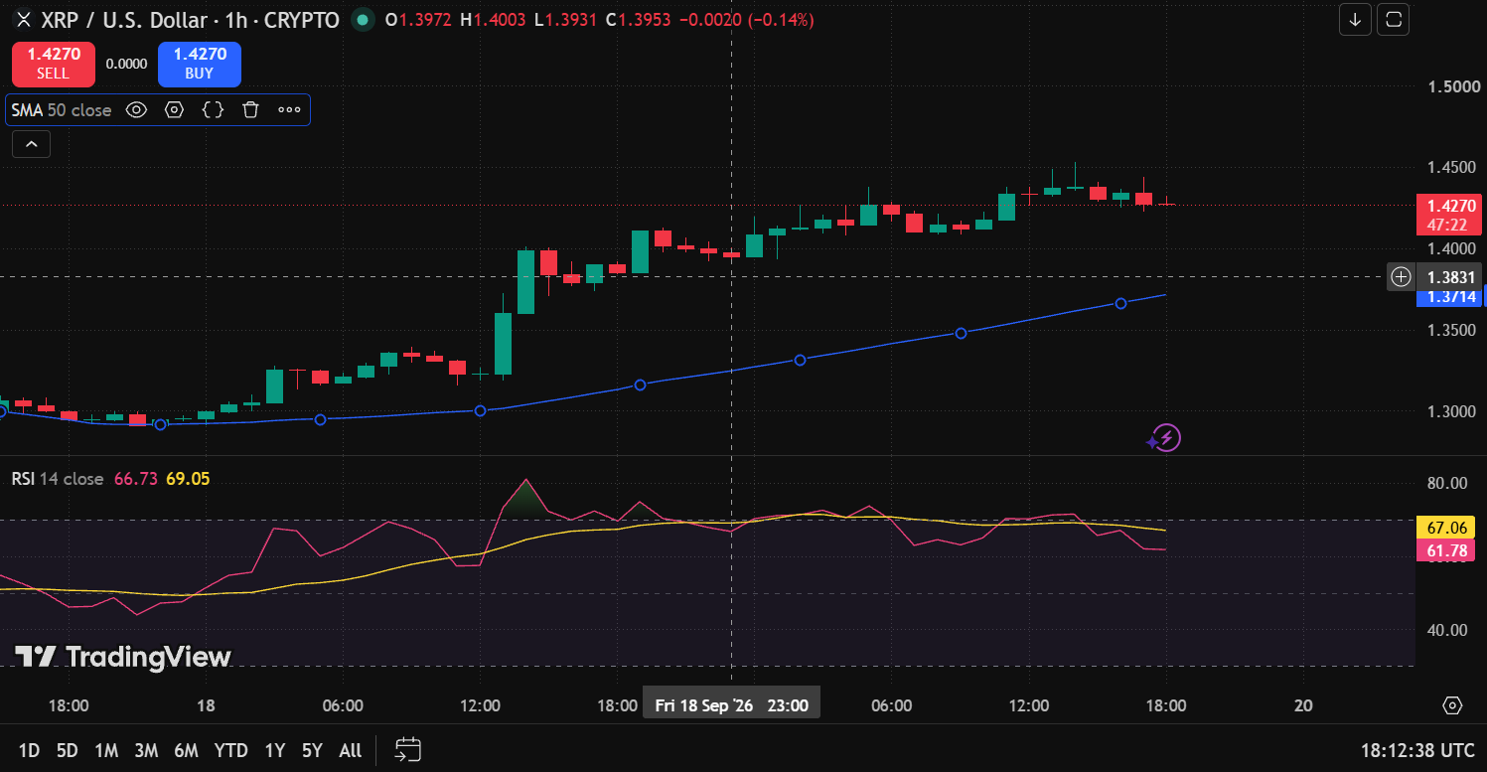

Observation | Sample Finding
Asset | XRPUSD
Timeframe | 1 Hour
Price Position | Above 50 SMA
SMA Direction | UPWARD
RSI Value | 63.07
RSI Zone | Neutral
Near Support | NO
Near Resistance | YES
Recent Candlestick | Bullish
Final Decision | Continuous observing
Reason | Although the price is in an upward trend above the 50 SMA with bullish momentum, it is currently testing a resistance level with neutral RSI, suggesting a prudent wait for a confirmed breakout or pullback before entering.

Exit Planning Sheet

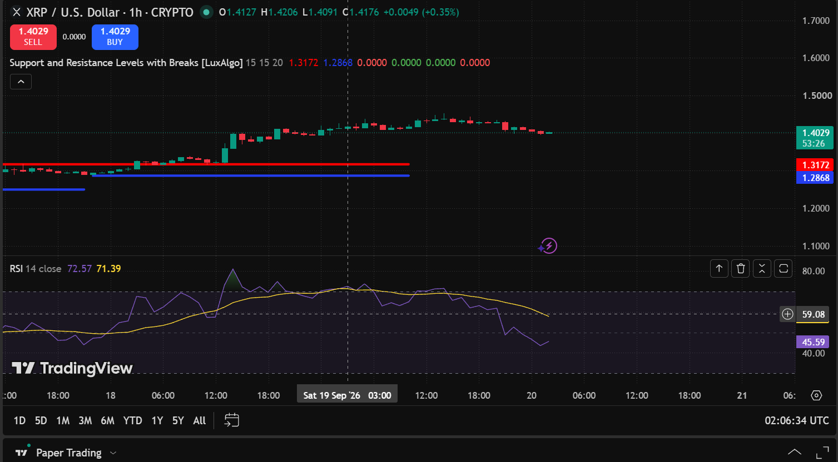

Observation | Sample Finding
Asset | XRPUSD
Timeframe | 1 Hour
Current Trade | short
Price Near Support / Resistance | Yes, near Resistance
RSI Value | 44.61
RSI Observation | Neutral
Candlestick | Bullish candle near Resistance
Final Decision | Hold
Reason | The price is near resistance, which may support a reversal, but the bullish candle shows buying pressure and the RSI at 44.61 is neutral. Therefore, there is not enough confirmation for a fresh short entry. Wait for a bearish candle or stronger confirmation before considering the short trade.

Trading Plan Review and Execution Report
Field | Details
Asset | BTCUSDT
Timeframe | 1 Hour
Trade Position | HOLD
Original Entry Plan | Near Resistance
Original Exit Plan | Near Resistance
Were Current Market Conditions Different from the Original Plan? | Yes
Were Any Revisions Made? | Yes
If Yes, Describe the Revisions | Entry was not taken; the trade was kept on hold and the market was observed for further confirmation.
Reason for the Revision | The market conditions did not provide sufficient confirmation for the planned trade, so entering the position was avoided.
Final Trading Decision | Continued Observing
Trade Status | No Trade Executed
Was the Trading Plan Followed? | Yes
Outcome (if executed) | Loss
Key Learning | Do not enter a trade without sufficient confirmation. If market conditions change from the original plan, wait and observe rather than forcing a trade.

